Name :Sk.Kashifa

Registration no :192121135

Recruitment system :

Class diagram :

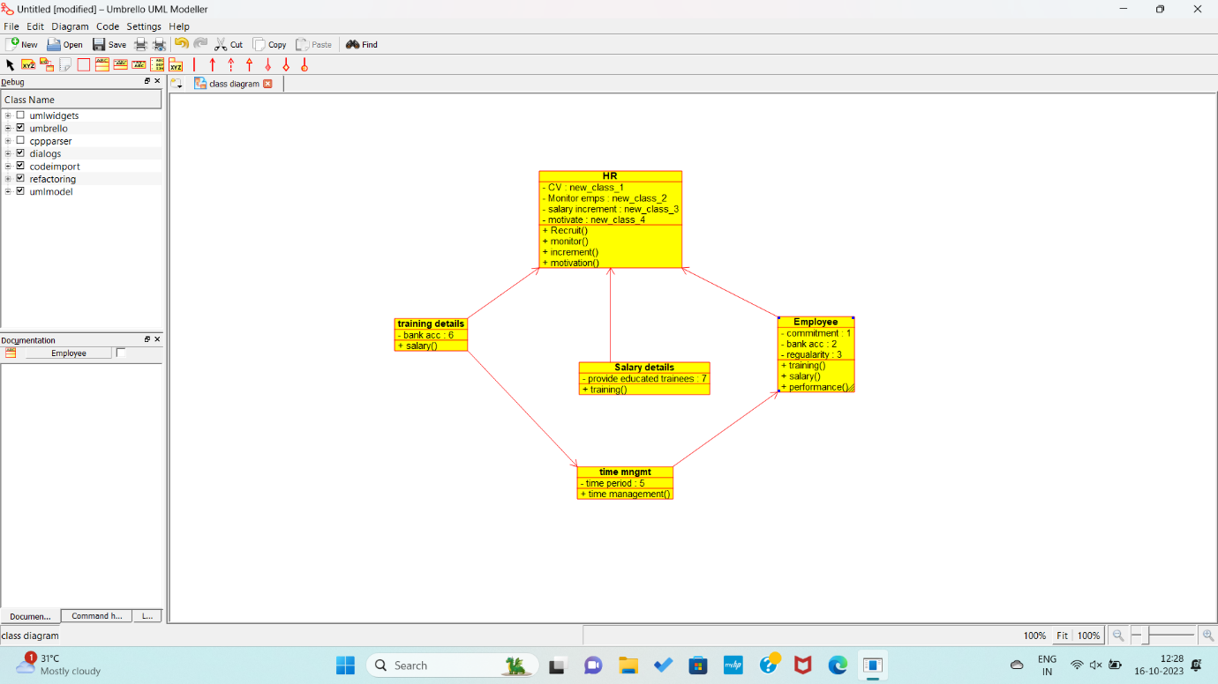

Usecase diagram :

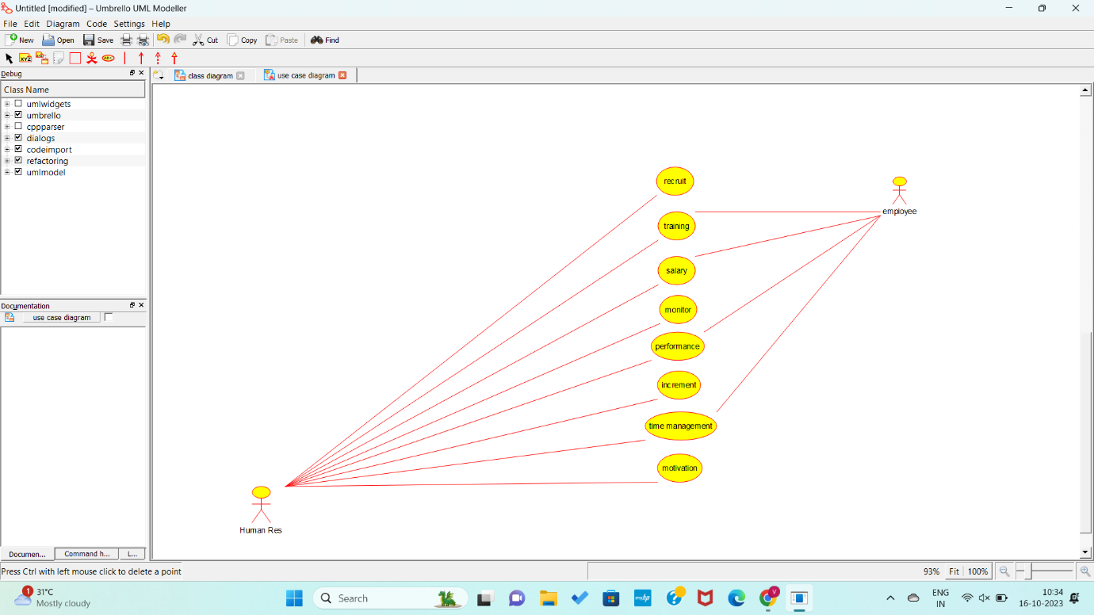

Sequence diagram :

